Local Weather Forecasting with Neural Network
by
Yee H. Wong

Abstract
Weather forecasting is usually made by collecting quantitative data about the current conditions of the atmosphere at a particular place and try to project how they will change based on scientific models developed from the understanding of atmospheric processes [1]. These quantitative data usually possess some patterns in them, for instance, a certain type of weather observed today often leads to a particular type of weather occurring in the next few days. Artificial neural networks are frequently employed to analyze such patterns so that when they are done training, they are able to predict some accurate outcomes given some inputs of interest. The objective of this project is to build an artificial neural network that models weather forecasting locally in Lafayette, Louisiana.

1. Introduction
Weather forecasting is an important application in science to predict the state of the atmosphere. With an accurate weather prediction, it is not only convenient for us to decide what type of clothing to put on for a particular type of day or to make plans for travel, it is also very crucial for the protection of the agriculture, life and property in cases like freeze warnings. Meteorologists are using numerical weather prediction method [1] based on mathematical models to forecast the weather for a given location. The construction of such models requires understanding of the atmospheric processes in order to determine which parameters have more impacts on which output conditions. However, similar models can also be constructed using a well trained artificial neural network which learns from the data patterns themselves. A problem with using these neural networks is that, without proper knowledge about how meteorology works, it is difficult to decide how far we need to look back in the past in order to predict the weather for a new day. A naive attempt used in this project is to look back for three consecutive days' weather conditions and forecast the weather for the new day.

To test the functionality of the proposed neural network, only the weather conditions of July and August will be used for training the network. The reason for choosing July and August is simply because of the fact that the weather conditions in these two months are very similar to each other. The weather parameters in both June and September vary slightly more from the ones in July and August, and the learning will be disrupted if we feed the network with weather conditions from all other months. In short, the model designed in this project will only be expected to correctly predict weather conditions in July and August. However, if the results are proven to be confidently accurate, it is possible to train new networks of the same type to be able to forecast weathers in other months with small dissimilarities in their weather conditions.

2. Related Work
Weather forecasting with artificial neural network has started been explored by computer scientists ever since the last few decades. In 1997 to 1998, Tony Hall published his manuscript which describes predicting the amount of precipitation in Dallas-Fort Worth area using neural network [2]. Further, Abhishek et al. examined the applicability of artificial neural network in predicting maximum temperature for 365 days a year in their paper [3], while Andrew Culclasure explored the prediction of minimum temperature and maximum wind speed in local area using a two-layer feed forward neural network [4]. Most of the works done on weather forecasting were focusing on one or two weather conditions, but for a longer period of time. In this project, the forecasting model is built to predict more than just a single weather factor, including maximum temperature and minimum temperature of a day, as well as wind speed, humidity percentage and precipitation, however, the input data is carefully restricted to handle only the ones in July and August.

3. Experimental Set Up
A feed-forward three layers neural network will be used to construct the architecture of the prediction model used in this project. The network consists of an input layer, a hidden layer, and an output layer. The input layer consists of fifteen inputs which represent the maximum temperature, minimum temperature, wind speed, humidity and precipitation of three consecutive days. These fifteen inputs are then partitioned into three neurons in the hidden layer, each represents one of the three days' weather conditions used in the input layer. Each of these hidden neurons is fully connected with the five dimensions (maximum temperature, minimum temperature, and so on) in the respective day only. For instance, the first hidden neuron is connected to first to fifth inputs while the second hidden neuron is connected to the sixth to tenth inputs. Finally, the three hidden neurons will be fully interconnected with the output layers which consists of five outputs, namely the five weather dimensions associated with the predicted day, which will be the day followed by the three consecutive days used in the input.

The input data will be read from files that store the historical weather data in the order of past to most recent. These data were collected from Weather Underground website [5] for the Lafayette, Louisiana region, where the data were originally obtained from the Lafayette Regional Airport's weather observation station. 71 years of historical weather data were able to be extracted from the website. Each year, only 62 days of data were used, which are the days in July and August. All input data are first normalized into the range of 0.0 to 1.0 before the feed-forward starts. These normalized values are then multiplied by the weights associated with the inputs and resulted in the net input of the hidden neurons. The net inputs are then undergone a sigmoid function in the form of:
where t is the net inputs. Each of the outputs of these functions will again be multiplied by the weights of hidden neurons, undergo another sigmoid function, and finally be one of the outputs of the network. No biases were used in this model. However, if further testing shows that adding biases can improve the performance of the network, they will be added appropriately in the future.
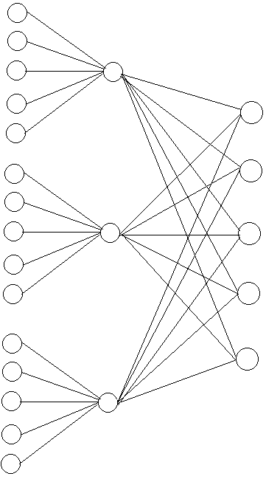
Figure 1: Three-layer neural network used in this project

The edges between input layer and hidden layer, as well as between hidden layer and output layer, carry different weights which are initialized to random decimal number between 0.0 and 1.0. As the training proceed, these weights get updated by back-propagation learning algorithm which will be discussed later. The weights between the hidden layer and output layer indicates the impacts of each day's weather conditions towards the correctness of the final output. For instance, day 1's weather conditions may have a different impact on one or more of the output dimensions compare to day 3's, therefore the weights may vary for each of these edges. Similarly, each of the five input dimensions of a selected day may have different contributions to the outputs. The job of the neural network is to figure out their contributions toward the total accuracy of the prediction and update these weights accordingly based on back-propagation algorithm.

To employ the back-propagation algorithm, residual sum of squares method is used to calculate the errors:

Each value of the five outputs is subtracted from the target value, the result is squared and divided by two. The error of every output is then summed up as the total error, which will be used to determine how much it will change corresponding to the changes of each weight. This is done by doing a partial derivative of the total error with respect to each weight, and subtract the result from the original weights respectively. The partial derivatives involve multiple chain-rules and are slightly different for hidden layer and input layer, in particular:

is used for the weights between hidden layer and output layer, assuming that we are updating weight 5 which is connected to output 1, where net stands for the net input before the activation function is applied, and out stands for the output after the net input has gone through the activation function. The chain-rule used for weights between input layer and hidden layer is similar except that we change all the net inputs and outputs of the output layer to the net inputs and outputs of the hidden layer.

When all weights have been updated, the next set of training data will be fed into the inputs and will undergo the same learning process. For each round, training data will be shifted down one row to obtain a new combination of three consecutive days' weather conditions. For instance in the second round, day 2's weather conditions used in previous round will now become day 1 in the input layer. As a result, we will have 31 training data sets in each month. This learning process is repeated for each training data set for approximately 4402 times, at this point the neural network has finished its training and is ready to be used for weather forecasting.
4. Results
The implementation of this neural network was done in Java. Each neuron is treated as an object of either class Input, Hidden, or Output, with their attributes being their output values and weights. Calculations were done in the main class for both feed-forward and back-propagation process. The following accuracy was obtained:

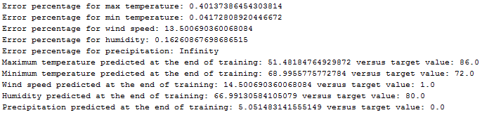
The percent errors were calculated by |(output – target)| / target. A roughly 60% accuracy for maximum temperature is obtained after 4402 trainings, and minimum temperature is as good as 96%, while humidity has a 84% correctness. However, wind speed and precipitation yield terrible results from this neural network. The case with wind speed is caused by the fact that almost 16 years of wind speed data were lost in the record, to manually fill them in for the network to use, I had to do some random sampling of wind speed between the minimum and maximum values observed from the records that were not lost. This may have caused a huge distortion in the wind data. However, even for the wind speeds that were not lost, the values varied in a non-uniform way that there are no useful patterns to be extracted from.

For precipitation, the infinity value is caused by divide by zero error since the target value is zero for the last record. However, even if we compare the 5.05 inch precipitation to the average 0.45 inch observed in the record, it is still highly inaccurate. To reason this outcome, again we look back at the historical precipitation data. It appears that forecasting the precipitation in each individual day using this neural network may not be a good idea because the way precipitation works is different from temperature where you can observe some value everyday. There can be several days with zero precipitation and followed by a few days of raining when the humidity reaches some level. While there may be some patterns between raining and not raining, it is unreliable to look at just three days of precipitation record and say what should come on the next day. It could be much more accurate to predict the total or average rain fall in a whole month using this particular model of neural network instead of daily forecasting.

5. Conclusion and future work
As the results stand, it can be concluded that the current model is acceptable to predict temperature and humidity of a given day. However, daily wind speed and precipitation have intolerable error and should not be forecasted using this model. It should also be noted that weather conditions changed slightly from 71 years ago to the present. However, if the patterns remain similar, it should still be practical to do forecasts based on these patterns.

A number of changes can be made to this model to test if the performance will improve, for example, using some biases, changing the input size to look back at more than just three days, or adjusting the number of weather dimensions used. On the other hand, for wind speed and precipitation, even though it is important to forecast them in a daily manner, it may still be interesting to do a monthly forecast to see if it yields a better result than daily forecast.

References
[1] Richardson and F. Lewis, “Weather Prediction by Numerical Process,” in Cambridge, England: Cambridge University Press, 1922. Available on-line at: Internet Archive.org.
[2] T. Hall, “Precipitation Forecasting Using a Neural Network,” in NOAA/NWS West Gulf River Forecast Center, Fort Worth, Texas, 1997 – 1998.
[3] K. Abhisheka, M.P. Singha, S. Ghoshb and A. Anandc, “Weather Forecasting Model using Artificial Neural Network,” in Procedia Technology Volume 4, 2012, Pages 311–318.
[4] A. Culclasure, “Using Neural Networks to Provide Local Weather Forecasts,” in Georgia Southern University, 2003.
[5] Weather Underground, https://www.wunderground.com

